
The AI Making Paradox

A big problem I see with AI is that it gives the illusion that you are good because it can render, code, or write the output of an idea with minimal prompting effort. This is false; you are not going to be good, and just like anything we do in design, it requires iteration. You have to practice it a lot to improve your outputs. AI is not different; it just shifts the goal posts.

Now that takes practice to understand why you’re designing, how you can articulate it, etc. But the role of sketching helps us get to the right solution faster, and tools that we’re now working with inside of whether it’s a pencil or AI or any of these other things, validate that opportunity, but then build on it.

Keep Reflecting

Designing with or without AI is a feedback loop, and we should be reinforcing this with our technology, not restricting it.

COMUNICASE Y CÚMPLASE

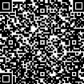
Firmado electrónicamente el 2025-12-21 22:38:57
DIANA YESENIA NOSSA FUENTES
Directora Técnica de Cobro Coactivo
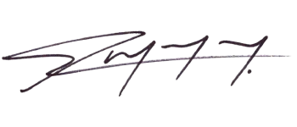  Firmado electrónicamente el 2025-12-21 22:18:07  Proyecta: HUGO RAMON QUINTERO GOMEZ  Cargo: Profesional Universitario |   Firmado electrónicamente el 2025-12-21 22:33:32  Revisa: DONALDO CEDEÑO DIAZ  Cargo: Profesional de Apoyo Cto 0018 de 2024

